Rashtriya Raksha University

**School of Information Technology, Artificial Intelligence & Cyber Security (SITAICS)**

At- Lavad, Dahegam, Gandhinagar, Gujarat-382305



**Practical File**

(Design & Analysis of Algorithms)

Name: Sarthak Sanay

Enrollment No: 230031101611051

Subject Name: Design & Analysis of Algorithms (G4AD18DAA)

Program: B.Tech CSE (with specialization in Cyber Security)

Year: 2nd year (Semester-IV)

This is to certify that **Mr. Sarthak Sanay** has satisfactorily completed **10** out of **10** practical work prescribed by SITAICS (School of Information Technology, Artificial Intelligence, & Cyber Security) at the **Networking** laboratory.

Dr. Ravi Sheth

SUBJECT INCHARGE

**INDEX**

**NAME:** SARTHAK SANAY

**ENROLLMENT NO:** 230031101611051

**SUBJECT:**  DESIGN & ANALYSIS OF ALGORITHMS

**SUBJECT CODE:** (G4AD18DAA)

| **SR.NO** | **TITLE** |
| --- | --- |
| 1. | Perform the different types of Strings Operations |
| 2. | Implement the Binary Search Algorithm & find its Time Complexity |
| 3. | Implement Merge Sort Algorithm |
| 4. | Implement Rod Cutting Problem by Divide and Conquer |
| 5. | Implement Rod Cutting Problem by Dynamic Programming |
| 6. | Implement Longest Common Subsequence in Strings |
| 7. | Implement Activity Selection Problem Using Greedy Algorithm |
| 8. | Implement Knapsack Problem Using Dynamic Programming. |
| 9. | Implement Knapsack Problem Using Greedy Algorithm |
| 10. | Implement the Huffman Coding Algorithm |

**PRACTICAL - 1**

# **AIM:** To Perform Different String Operations

**CODE:**

**// Write a program in C to implement string functions copy(), compare(), and concatenate() by clearly defining it on your own.**

**#include <stdio.h>**

**#include <string.h>**

**void sanCopy(char a[], char b[]) {**

**int i;**

**for(i = 0; b[i] != '\0'; i++) {**

**a[i] = b[i];**

**}**

**a[i] = '\0';**

**printf("\nCopied string: %s\n", a);**

**}**

**void sanCompare(char a[], char b[]) {**

**int i = 0;**

**// compare the strings character by character**

**while (a[i] != '\0' && b[i] != '\0') {**

**if (a[i] < b[i]) {**

**printf("\nString 1 is smaller than String 2.\n");**

**return;**

**} else if (a[i] > b[i]) {**

**printf("\nString 1 is greater than String 2.\n");**

**return;**

**}**

**i++;**

**}**

**if (a[i] == '\0' && b[i] != '\0') {**

**printf("\nString 1 is smaller than String 2.\n");**

**}**

**else if (b[i] == '\0' && a[i] != '\0') {**

**printf("\nString 1 is greater than String 2.\n");**

**}**

**else {**

**printf("\nBoth strings are equal.\n");**

**}**

**}**

**void sanConcatenate(char a[], char b[]) {**

**int aLen = strlen(a);**

**int bLen = strlen(b);**

**int totalLen = aLen + bLen;**

**char concat[totalLen + 1]; // +1 for null terminator**

**int count = 0;**

**for(int i = 0; i < aLen; i++, count++) {**

**concat[count] = a[i];**

**}**

**for(int j = 0; j < bLen; j++, count++) {**

**concat[count] = b[j];**

**}**

**concat[count] = '\0';**

**printf("\n%s\n", concat);**

**}**

**int main() {**

**int ch = 1;**

**char s1[20], s2[20];**

**printf("Enter 1st string: ");**

**fgets(s1, sizeof(s1), stdin);**

**s1[strcspn(s1, "\n")] = 0; // Remove trailing newline**

**printf("Enter 2nd string: ");**

**fgets(s2, sizeof(s2), stdin);**

**s2[strcspn(s2, "\n")] = 0; // Remove trailing newline**

**while (ch != 0) {**

**printf("\nEnter 1 to COPY string."**

**"\nEnter 2 to COMPARE string."**

**"\nEnter 3 to CONCATENATE string."**

**"\nEnter 0 to EXIT."**

**"\nEnter your choice: ");**

**if (scanf("%d", &ch) != 1) {**

**printf("\nInvalid input. Please enter a number.\n");**

**continue;**

**}**

**switch(ch) {**

**case 1:**

**sanCopy(s1, s2);**

**break;**

**case 2:**

**sanCompare(s1, s2);**

**break;**

**case 3:**

**sanConcatenate(s1, s2);**

**break;**

**case 0:**

**printf("\nProgram exited successfully!\n");**

**break;**

**default:**

**printf("Enter correct choice.\n");**

**}**

**}**

**return 0;**

**}**

**OUTPUT:**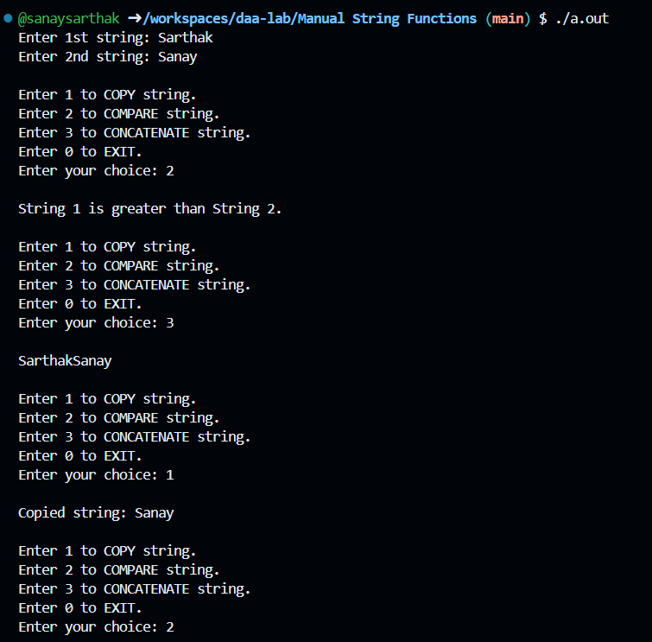

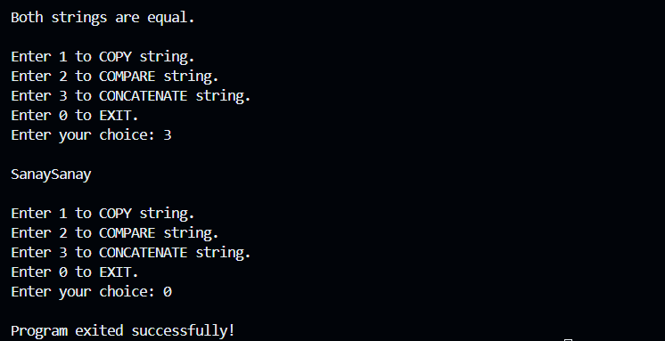

**PRACTICAL - 2**

# **AIM:** To implement the Binary Search Algorithm and find its Time Complexity

**CODE:**

**#include <stdio.h>**

**#include <sys/time.h>**

**int binarySearch(int array[], int startIndex, int endIndex, int x)**

**{**

**if (endIndex >= startIndex) // used for checking if the position is at the extreme ends of the array or not**

**{**

**int mid = startIndex + (endIndex - startIndex) / 2;**

**// If found at mid, then return it**

**if(array[mid] == x)**

**return mid;**

**// Search the left half**

**else if(array[mid] > x)**

**return binarySearch(array, startIndex, mid - 1,x);**

**// Search the right half**

**else**

**return binarySearch(array, mid + 1, endIndex, x);**

**}**

**return -1;**

**}**

**int main()**

**{**

**struct timeval start, end;**

**int size, ele;**

**printf("Enter the size of an array: ");**

**scanf("%d", &size);**

**int arr[size];**

**printf("\nEnter elements in the array :-\n");**

**for(int i=0; i<size; i++)**

**{**

**printf("Enter element %d : ", i);**

**scanf("%d", &arr[i]);**

**}**

**printf("\nEnter a number to search it in the array: ");**

**scanf("%d", &ele);**

**printf("Performing Binary Search algorithm to check whether the number is in the array or not.\n");**

**gettimeofday(&start, NULL);**

**printf("\nTime before function call = %ld microseconds\n", start.tv_usec);**

**int res = binarySearch(arr, 0, size-1, ele);**

**if (res == -1)**

**printf("The number %d is not in the Array.", ele);**

**else**

**printf("The number %d is present at index %d.\n", ele, res);**

**gettimeofday(&end, NULL);**

**printf("Time after function call = %ld microseconds\n", end.tv_usec);**

**printf("\nTotal running time = %ld microseconds\n", end.tv_usec - start.tv_usec);**

**return 0;**

**}**

**P.T.O.**

**OUTPUT:**

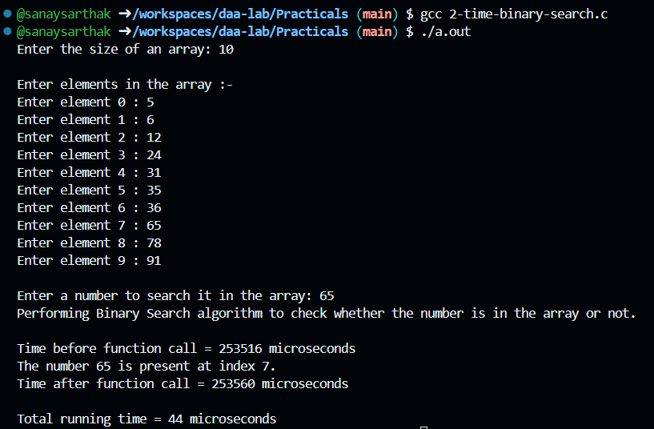

**PRACTICAL - 3**

# **AIM:** To implement the Merge Sort Algorithm

**CODE:**

**#include <stdio.h>**

**// Function to merge two halves of the array**

**void merge(int arr[], int left, int mid, int right) {**

**int n1 = mid - left + 1;**

**int n2 = right - mid;**

**int leftArr[n1], rightArr[n2];**

**for (int i = 0; i < n1; i++)**

**leftArr[i] = arr[left + i];**

**for (int i = 0; i < n2; i++)**

**rightArr[i] = arr[mid + 1 + i];**

**// Merge the temp arrays back into arr**

**int i = 0, j = 0, k = left;**

**while (i < n1 && j < n2) {**

**if (leftArr[i] <= rightArr[j]) {**

**arr[k] = leftArr[i];**

**i++;**

**} else {**

**arr[k] = rightArr[j];**

**j++;**

**}**

**k++;**

**}**

**while (i < n1) {**

**arr[k] = leftArr[i];**

**i++;**

**k++;**

**}**

**while (j < n2) {**

**arr[k] = rightArr[j];**

**j++;**

**k++;**

**}**

**}**

**void mergeSort(int arr[], int left, int right) {**

**if (left < right) {**

**int mid = left + (right - left) / 2;**

**// Recursively sort first and second halves**

**mergeSort(arr, left, mid);**

**mergeSort(arr, mid + 1, right);**

**// Merge the sorted halves**

**merge(arr, left, mid, right);**

**}**

**}**

**void printArray(int arr[], int size) {**

**for (int i = 0; i < size; i++) {**

**printf("%d ", arr[i]);**

**}**

**printf("\n");**

**}**

**int main() {**

**int n;**

**printf("Enter the number of elements: ");**

**scanf("%d", &n);**

**int arr[n];**

**printf("Enter the elements: \n");**

**for (int i = 0; i < n; i++) {**

**scanf("%d", &arr[i]);**

**}**

**printf("Original Array: \n");**

**printArray(arr, n);**

**mergeSort(arr, 0, n - 1);**

**printf("\nSorted Array: \n");**

**printArray(arr, n);**

**return 0;**

**}**

**OUTPUT:**

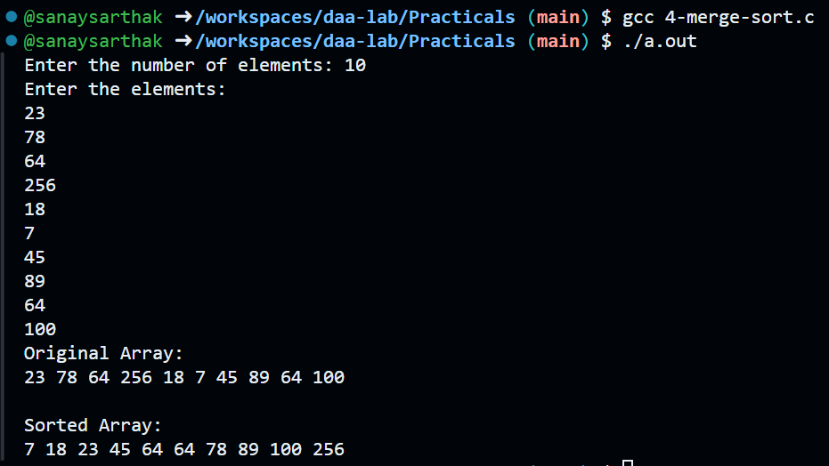

**PRACTICAL - 4**

# **AIM:** To solve the Rod Cutting Problem using the Divide and Conquer Approach

**CODE:**

**#include <stdio.h>**

**// Function to compute the maximum value using a divide-and-conquer approach**

**int cutRod(int price[], int n) {**

**int max_val = 0;**

**// Try every possible first cut**

**for (int i = 0; i < n; i++) {**

**int revenue = price[i] + cutRod(price, n - i - 1);**

**if (revenue > max_val) {**

**max_val = revenue;**

**}**

**}**

**return max_val;**

**}**

**int main() {**

**// Example price list (for rod lengths 1 to 10)**

**int price[] = {1, 5, 8, 9, 10, 17, 17, 20, 24, 30};**

**int n = sizeof(price) / sizeof(price[0]);**

**int user_len;**

**printf("Enter length: ");**

**scanf("%d", &user_len);**

**if (user_len >= 1 && user_len <= n)**

**printf("Maximum cost you can get: %d\n", cutRod(price, user_len));**

**else**

**printf("Invalid length! Enter a value between 1 and %d\n", n);**

**return 0;**

**}**

**OUTPUT:**

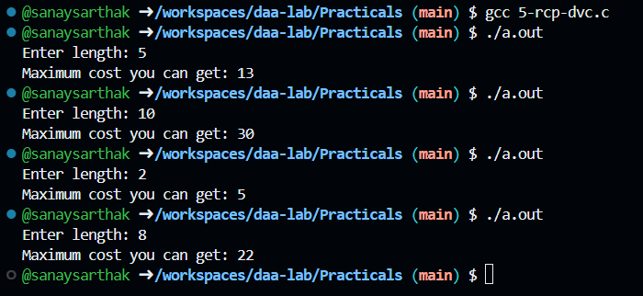

**PRACTICAL - 5**

# **AIM:** To solve the Rod Cutting Problem using the Dynamic Programming Approach

**CODE:**

**#include <stdio.h>**

**// Function to compute the maximum value using dynamic‑programming approach**

**int cutRod(int price[], int n) {**

**// dp[j] will hold the maximum revenue for a rod of length j**

**int dp[n + 1];**

**dp[0] = 0;**

**for (int j = 1; j <= n; j++) {**

**int max_val = 0;**

**// try cutting off a first piece of length (i+1), leaving j-(i+1)**

**for (int i = 0; i < j; i++) {**

**int revenue = price[i] + dp[j - i - 1];**

**if (revenue > max_val) {**

**max_val = revenue;**

**}**

**}**

**dp[j] = max_val;**

**}**

**return dp[n];**

**}**

**int main() {**

**// Example price list (for rod lengths 1 to 10)**

**int price[] = {1, 5, 8, 9, 10, 17, 17, 20, 24, 30};**

**int n = sizeof(price) / sizeof(price[0]);**

**int user_len;**

**printf("Enter length: ");**

**scanf("%d", &user_len);**

**if (user_len >= 1 && user_len <= n)**

**printf("Maximum cost you can get: %d\n", cutRod(price, user_len));**

**else**

**printf("Invalid length! Enter a value between 1 and %d\n", n);**

**return 0;**

**}**

**OUTPUT:**

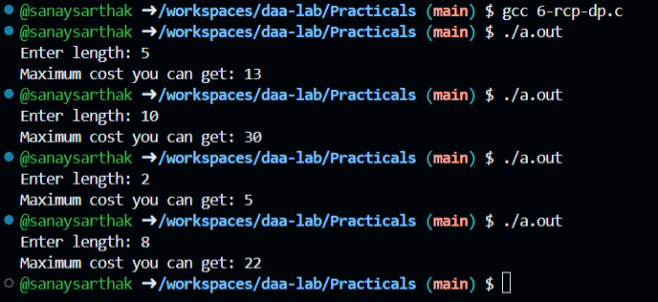

**PRACTICAL - 6**

# **AIM:** To implement the code for LCS (Longest Common Subsequence) in strings, count the total number of subsequences formed, and display the longest one.

**CODE:**

**#include <stdio.h>**

**#include <string.h>**

**int LCSLength(char X[], char Y[], int m, int n, int dp[][n+1]) {**

**for (int i = 0; i <= m; i++) {**

**for (int j = 0; j <= n; j++) {**

**if (i == 0 || j == 0) {**

**dp[i][j] = 0;**

**} else if (X[i-1] == Y[j-1]) {**

**dp[i][j] = dp[i-1][j-1] + 1;**

**} else {**

**dp[i][j] = (dp[i-1][j] > dp[i][j-1]) ? dp[i-1][j] : dp[i][j-1];**

**}**

**}**

**}**

**return dp[m][n];**

**}**

**void printLCS(char X[], char Y[], int m, int n, int dp[][n+1]) {**

**char lcs[dp[m][n] + 1];**

**int i = m, j = n, index = dp[m][n];**

**lcs[index] = '\0';**

**while (i > 0 && j > 0) {**

**if (X[i-1] == Y[j-1]) {**

**lcs[--index] = X[i-1];**

**i--; j--;**

**} else if (dp[i-1][j] > dp[i][j-1]) {**

**i--;**

**} else {**

**j--;**

**}**

**}**

**printf("\nLongest Common Subsequence: %s\n", lcs);**

**printf("\n");**

**}**

**int main() {**

**char X[] = "ABDECGF";**

**char Y[] = "ACBDFGH";**

**int m = strlen(X);**

**int n = strlen(Y);**

**int dp[m+1][n+1];**

**// Calculate the length of LCS**

**LCSLength(X, Y, m, n, dp);**

**printLCS(X, Y, m, n, dp);**

**return 0;**

**}**

**OUTPUT:**

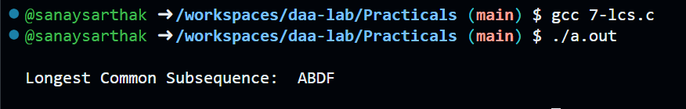

**PRACTICAL - 7**

# **AIM:** To implement the Activity Selection Problem using Greedy Algorithm.

**CODE:**

**#include <stdio.h>**

**#include <stdlib.h>**

**struct Activity {**

**int start;**

**int finish;**

**};**

**// Swap function for sorting**

**void swap(struct Activity *a, struct Activity *b) {**

**struct Activity temp = *a;**

**\*a = *b;**

**\*b = temp;**

**}**

**// Sort activities by finish time**

**void sortActivities(struct Activity activities[], int n) {**

**for (int i = 0; i < n - 1; i++) {**

**for (int j = i + 1; j < n; j++) {**

**if (activities[i].finish > activities[j].finish) {**

**swap(&activities[i], &activities[j]);**

**}**

**}**

**}**

**}**

**// Function to select activities**

**void activitySelection(struct Activity activities[], int n) {**

**// Sort by finish time**

**sortActivities(activities, n);**

**printf("\nSelected activities (start, finish):\n");**

**int lastFinish = activities[0].finish;**

**printf("(%d, %d)\n", activities[0].start, activities[0].finish);**

**// Select remaining compatible activities**

**for (int i = 1; i < n; i++) {**

**if (activities[i].start >= lastFinish) {**

**printf("(%d, %d)\n", activities[i].start, activities[i].finish);**

**lastFinish = activities[i].finish;**

**}**

**}**

**}**

**int main() {**

**int n;**

**printf("Enter the number of activities: ");**

**scanf("%d", &n);**

**struct Activity activities[n];**

**printf("Enter start and finish times of each activity:\n");**

**for (int i = 0; i < n; i++) {**

**printf("Activity %d - Start: ", i + 1);**

**scanf("%d", &activities[i].start);**

**printf("Activity %d - Finish: ", i + 1);**

**scanf("%d", &activities[i].finish);**

**}**

**activitySelection(activities, n);**

**return 0;**

**}**

**P.T.O.**

**OUTPUT:**

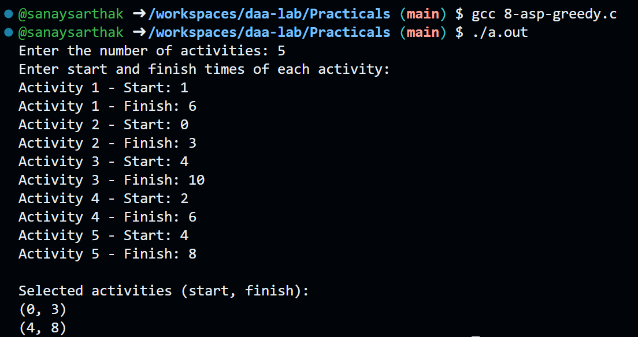

**PRACTICAL - 8**

# **AIM:** To implement the Knapsack Problem using Dynamic Programming.

**CODE:**

**#include <stdio.h>**

**#include <stdlib.h>**

**int max(int a, int b) {**

**return (a > b) ? a : b;**

**}**

**// Knapsack DP function**

**int knapsack(int W, int weight[], int value[], int n) {**

**int dp[n + 1][W + 1];**

**// Build table dp[][] in bottom-up manner**

**for (int i = 0; i <= n; i++) {**

**for (int w = 0; w <= W; w++) {**

**if (i == 0 || w == 0)**

**dp[i][w] = 0;**

**else if (weight[i - 1] <= w)**

**dp[i][w] = max(value[i - 1] + dp[i - 1][w - weight[i - 1]], dp[i - 1][w]);**

**else**

**dp[i][w] = dp[i - 1][w];**

**}**

**}**

**// Track selected items**

**int selected[n];**

**for (int i = 0; i < n; i++) selected[i] = 0;**

**int w = W;**

**for (int i = n; i > 0 && w > 0; i--) {**

**if (dp[i][w] != dp[i - 1][w]) {**

**selected[i - 1] = 1;**

**w -= weight[i - 1];**

**}**

**}**

**printf("\nAll entered item values: ");**

**for (int i = 0; i < n; i++) {**

**printf("%d ", value[i]);**

**}**

**printf("\nAll entered item weights: ");**

**for (int i = 0; i < n; i++) {**

**printf("%d ", weight[i]);**

**}**

**printf("\n\nSelected item indices (0-based): ");**

**for (int i = 0; i < n; i++) {**

**if (selected[i])**

**printf("%d ", i);**

**}**

**printf("\nSelected item values: ");**

**for (int i = 0; i < n; i++) {**

**if (selected[i])**

**printf("%d ", value[i]);**

**}**

**printf("\nSelected item weights: ");**

**for (int i = 0; i < n; i++) {**

**if (selected[i])**

**printf("%d ", weight[i]);**

**}**

**printf("\n");**

**return dp[n][W];**

**}**

**int main() {**

**int n, W;**

**printf("Enter number of items: ");**

**scanf("%d", &n);**

**int value[n], weight[n];**

**printf("Enter the values of the items:\n");**

**for (int i = 0; i < n; i++) {**

**scanf("%d", &value[i]);**

**}**

**printf("Enter the weights of the items:\n");**

**for (int i = 0; i < n; i++) {**

**scanf("%d", &weight[i]);**

**}**

**printf("Enter the capacity of the knapsack: ");**

**scanf("%d", &W);**

**int result = knapsack(W, weight, value, n);**

**printf("\nMaximum value in knapsack of capacity %d = %d\n", W, result);**

**return 0;**

**}**

**OUTPUT:**

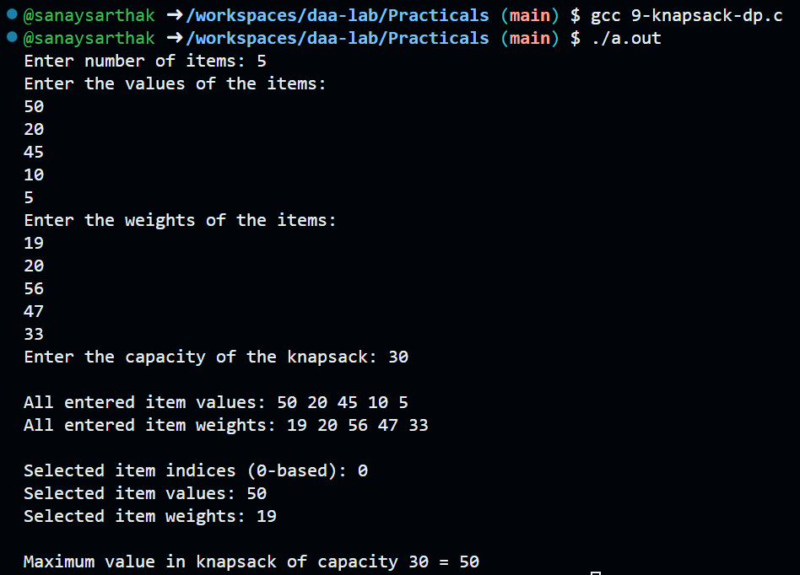

**PRACTICAL - 9**

# **AIM:** To implement the Knapsack Problem using Greedy Algorithm.

**CODE:**

**#include <stdio.h>**

**#include <stdlib.h>**

**struct Item {**

**int value;**

**int weight;**

**float ratio;**

**};**

**// Function to compare items by value/weight ratio (descending)**

**int compare(const void *a, const void *b) {**

**float r1 = ((struct Item *)a)->ratio;**

**float r2 = ((struct Item *)b)->ratio;**

**return (r2 > r1) - (r2 < r1);**

**}**

**int main() {**

**int n;**

**float capacity;**

**printf("Enter number of items: ");**

**scanf("%d", &n);**

**struct Item items[n];**

**printf("Enter the values of the items:\n");**

**for (int i = 0; i < n; i++) {**

**scanf("%d", &items[i].value);**

**}**

**printf("Enter the weights of the items:\n");**

**for (int i = 0; i < n; i++) {**

**scanf("%d", &items[i].weight);**

**items[i].ratio = (float)items[i].value / items[i].weight;**

**}**

**printf("Enter the capacity of the knapsack: ");**

**scanf("%f", &capacity);**

**// Sort items by ratio**

**qsort(items, n, sizeof(struct Item), compare);**

**float total_value = 0.0;**

**float total_weight = 0.0;**

**printf("\nSelected items (value, weight, fraction):\n");**

**for (int i = 0; i < n && capacity > 0; i++) {**

**if (items[i].weight <= capacity) {**

**// Take full item**

**capacity -= items[i].weight;**

**total_value += items[i].value;**

**total_weight += items[i].weight;**

**printf("(%d, %d, 1.00)\n", items[i].value, items[i].weight);**

**}**

**else {**

**// Take fractional part**

**float fraction = capacity / items[i].weight;**

**total_value += items[i].value * fraction;**

**total_weight += items[i].weight * fraction;**

**printf("(%d, %d, %.2f)\n", items[i].value, items[i].weight, fraction);**

**capacity = 0; // Knapsack full**

**}**

**}**

**printf("\nTotal weight used: %.2f\n", total_weight);**

**printf("Maximum value in knapsack = %.2f\n", total_value);**

**return 0;**

**}**

**P.T.O.**

**OUTPUT:**

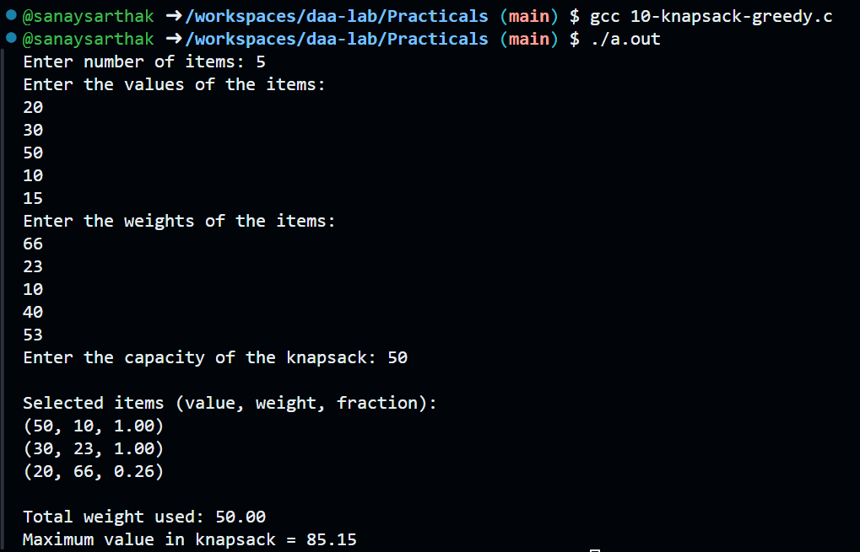

**PRACTICAL - 10**

# **AIM:** To implement the Huffman Coding Algorithm

**CODE:**

**#include <stdio.h>**

**#include <stdlib.h>**

**#define MAX_CODE_LEN 100**

**typedef struct Node {**

**char ch;**

**int freq;**

**struct Node *l, *r;**

**} Node;**

**Node* new_node(char c, int f) {**

**Node* n = malloc(sizeof(Node));**

**n->ch = c;**

**n->freq = f;**

**n->l = n->r = NULL;**

**return n;**

**}**

**int cmp_node(const void *a, const void *b) {**

**Node *na = *(Node**)a;**

**Node *nb = *(Node**)b;**

**return na->freq - nb->freq;**

**}**

**void print_codes(Node *root, char code[], int depth) {**

**if (!root) return;**

**if (!root->l && !root->r) {**

**code[depth] = '\0';**

**printf("'%c' -> %s\n", root->ch, code);**

**} else {**

**code[depth] = '0';**

**print_codes(root->l, code, depth+1);**

**code[depth] = '1';**

**print_codes(root->r, code, depth+1);**

**}**

**}**

**int main(void) {**

**int n;**

**printf("Enter number of characters: ");**

**if (scanf("%d", &n)!=1 || n<=0) return 0;**

**// read inputs**

**char *chars = malloc(n);**

**int *freqs = malloc(n * sizeof(int));**

**printf("\n");**

**for (int i = 0; i < n; i++) {**

**printf("Character %d: ", i+1);**

**scanf(" %c", &chars[i]);**

**printf("Frequency of '%c': ", chars[i]);**

**scanf("%d", &freqs[i]);**

**printf("\n");**

**}**

**Node **arr = malloc(n * sizeof(Node*));**

**for (int i = 0; i < n; i++)**

**arr[i] = new_node(chars[i], freqs[i]);**

**int sz = n;**

**while (sz > 1) {**

**qsort(arr, sz, sizeof(Node*), cmp_node);**

**Node *a = arr[0], *b = arr[1];**

**Node *m = new_node('\0', a->freq + b->freq);**

**m->l = a; m->r = b;**

**arr[1] = m;**

**arr[0] = arr[sz-1];**

**sz--;**

**}**

**printf("\nGenerated Huffman Codes:\n");**

**char code[MAX_CODE_LEN];**

**print_codes(arr[0], code, 0);**

**return 0;**

**}**

**OUTPUT:**

